Dangling pointer:
A pointer is declared and some variable address also assigned. After some time the variable is deleted from memory. But still the pointer is storing the deleted variable address and giving the value. This kind of pointer is called dangling pointer and to avoid this initialize with NULL.
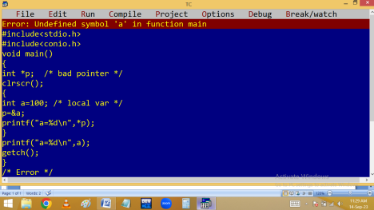
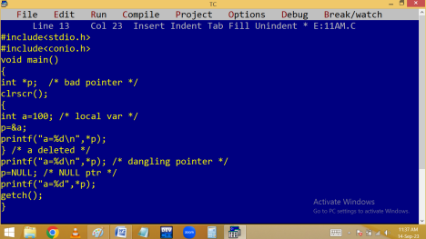
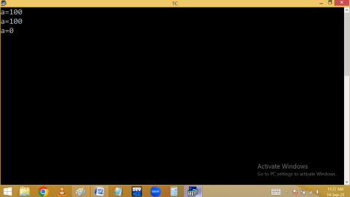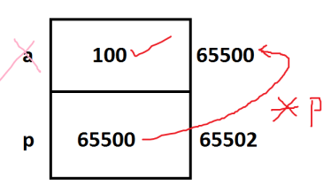void / generic pointer: pointer stores only the same type of variable address. Using void pointer we can store any type of address. But before going to use void pointer, explicit type casting is mandatory. Void pointer takes 2 bytes memory and used to handle dynamic array.
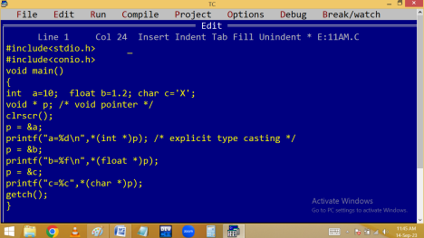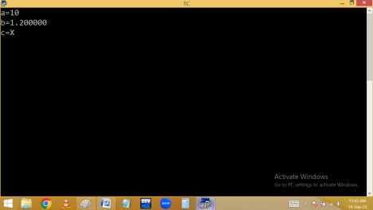
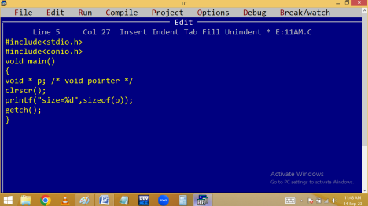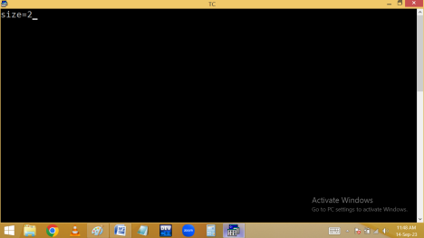Pointer arithmetic:
We can do the operations line +, -, =, == , ++ and - - on pointers. But we can’t do *, %, / on pointers.
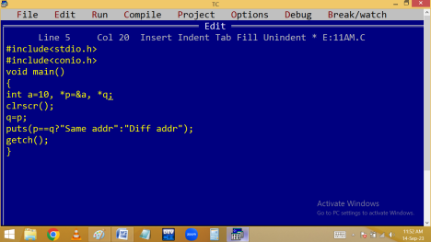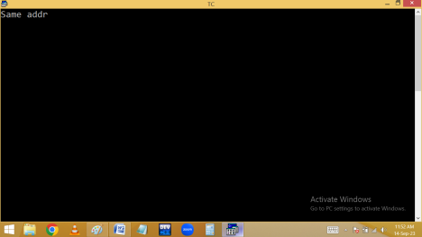
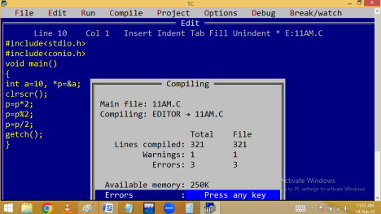
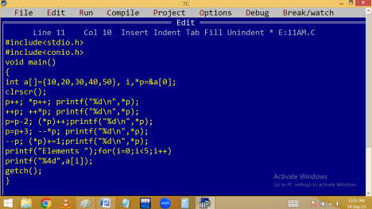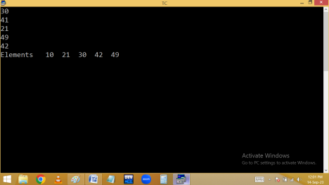
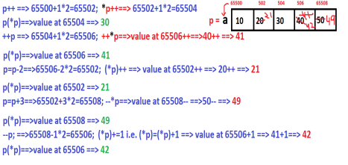
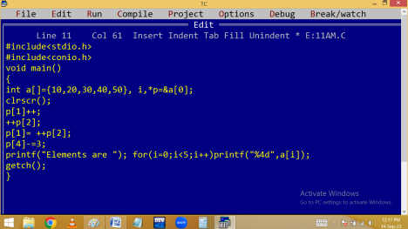
MEMORY MANAGEMENT
To store anything in our computer, we should have to allocate the memory first.
This memory allocation is conducted in two ways.
1. Static memory allocation.
2. Dynamic memory allocation.
In static memory allocation, the memory specified at compile/design time, based on the data type or array size. This type of memory management is called compile
time memory management [compiler indicates memory and O.S allocates the memory].
In static memory allocation, the memory size is fixed at compile time and we can’t change this memory size at run time. It causes some times memory wastage / shortage.
To avoid this problem, the only solution is dynamic memory allocation.
In dynamic memory allocation, the memory is allocated at run time, based on the user input, instantly. This type of memory management is called run time memory management.
To conduct dynamic memory allocation, we should have to use pointers.
In dynamic memory allocation the memory is allocated in HEAP area.
To manage the dynamic memory, we are using some predefined functions like
⮚ malloc()
⮚ calloc()
⮚ realloc()
⮚ free()
All these functions are available in <alloc.h>
malloc(), realloc(), calloc() functions are able to allocate the memory of 64KB Maximum at a time.
To allocate more than 64KB memory, use the functions
⮚ farmalloc()
⮚ farcalloc()
⮚ farrealloc().
Note:
when we are working with dynamic memory allocation, we have to allocate the memory for any data type. Due to this all these functions return datatype is void *, which is a generic type. Due to this we should have to provide explicit type casting for all these functions.

malloc() | calloc()
Block Memory allocation | Contiguous memory blocks allocation
Allocates memory in bytes form | Allocates memory in blocks form.
Initial values garbage Initial values 0

One argument required | Two arguments required
Used for normal variables | Used for array type variables

Syntax:
void * malloc(bytes);
void * calloc(no of blocks, block_size);
free(): It is used to release the memory allocated by malloc(), calloc() and realloc().
Syntax: void free(pointer);
realloc(): It is used to extend the memory allocated by malloc() or calloc() at runtime. Working style is similar to malloc().
Syntax: void * realloc(oldptr, newsize);

